Important Mongo DB notes

<https://www.mongodb.com/use-cases>

<https://www.mongodb.com/use-cases/single-view>

<https://www.mongodb.com/industries/financial-services>

<https://www.mongodb.com/presentations/event-based-subscription-mongodb>

Citi group was having performance issues with relational database. They started using mongo db around 2 years ago.

1. What business problem did the company face?

Citi group was having performance issues with relational database. They started using mongo db around 2 years ago just as poc. Either to migrate to oracle or other choices. They chose mongo DB because it is good for document database. They chose Mongo DB based on data/query pattern. 

te

Data model example

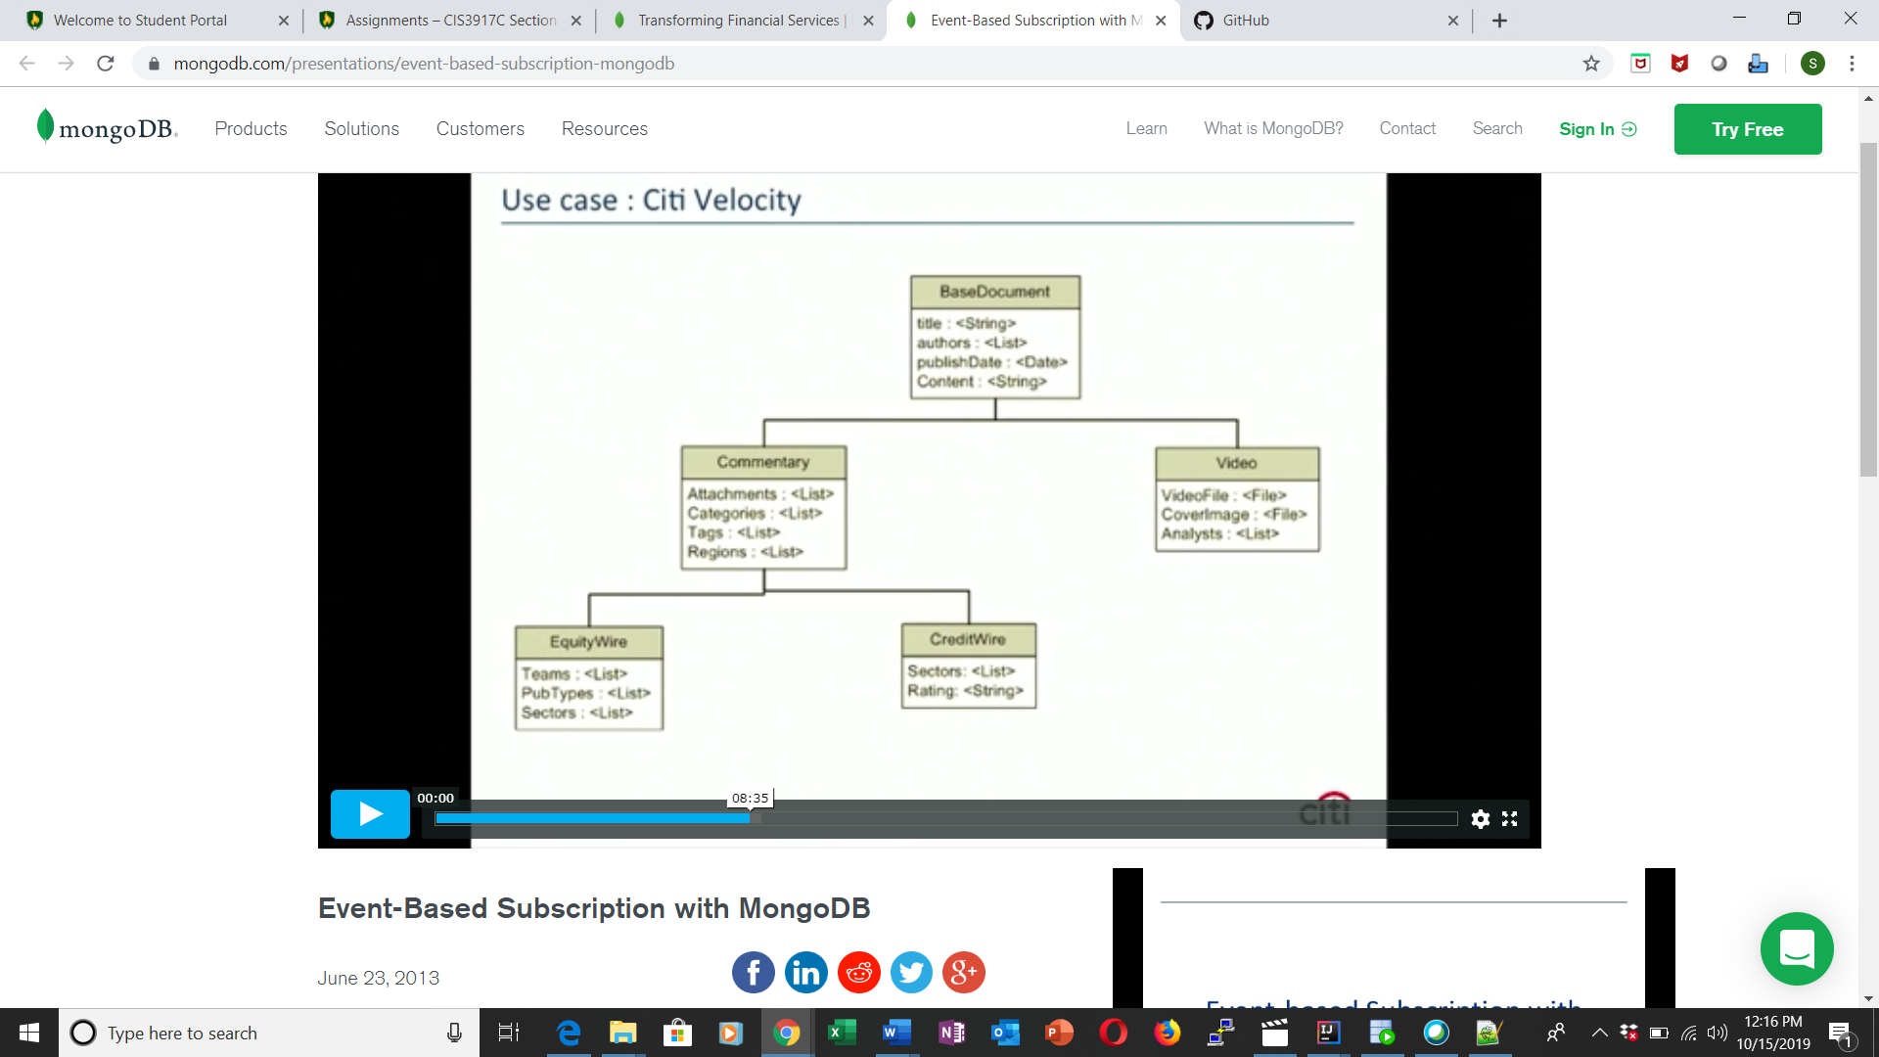

In order to make this data model in relational database Citi had 30 different tables which made the performance very slow. And they had to so many joins to bring this data together.

Actual problem

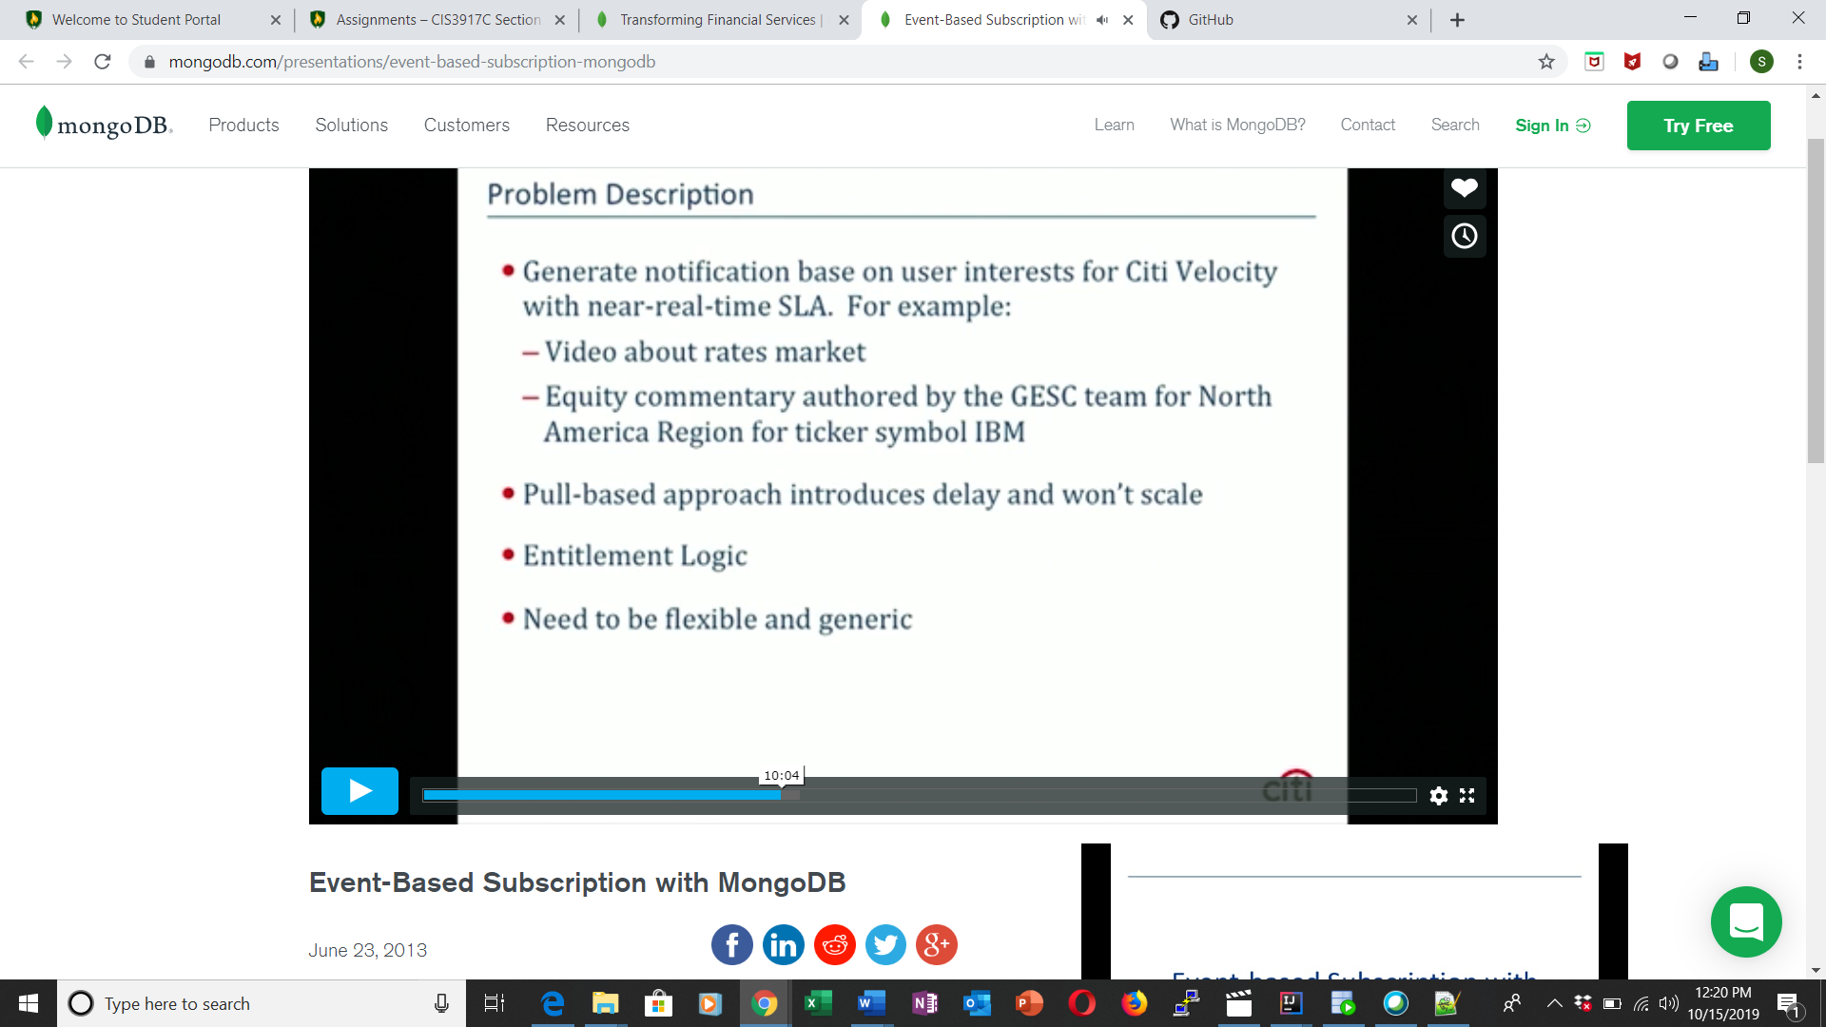

1. Was there a system of application developed? Explain what function(s) the system provides.

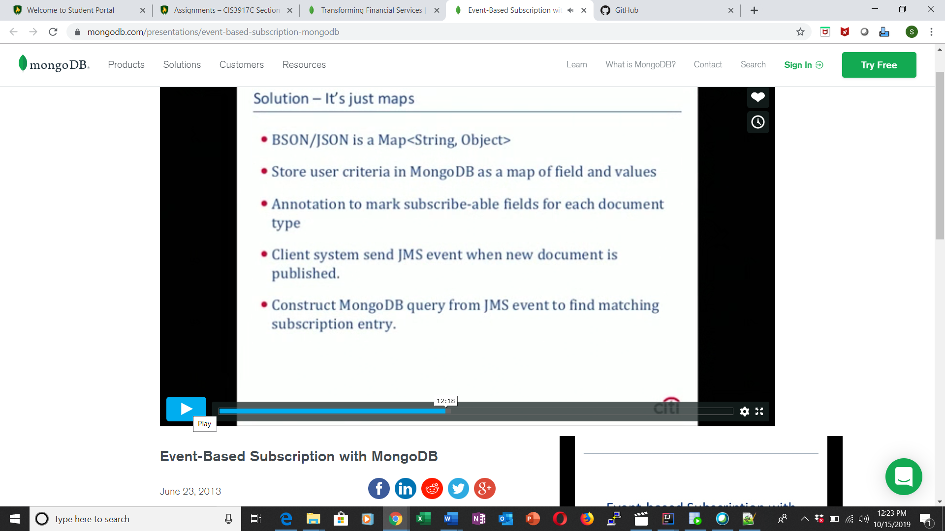

.All the fields is key value pair and can be represented as key value object. Use a annotation to incoming to For example if user is interested in equity from north America we can save it as criteria in Mogo DB.and then use annotation to turn a incoming document to incoming query.so the basic idea is that we taking a incoming document turn it into mongo db query and query against user interest table. instead of issuing 10000 queries for 10000 interest, I this solution do is will generate one query against all the interest. And you get all the results back which gets what user wants to read.



If you put @document then java understand this is an object which can be saved in Mongo DB.

There is a @ID annotation which tells these variables are id field. Which will autogenerated from mongo

@DBref, mongo DB don’t have concept of joins you can do two different collections together and do refrencing.

So, in above example here is collection called users where each subscription needs to go to. To the spring frame work save this as a mongo db refrence. This is application level joint. This is the map of sting this where they saved the user intrest 

Example of what will criteria will look like

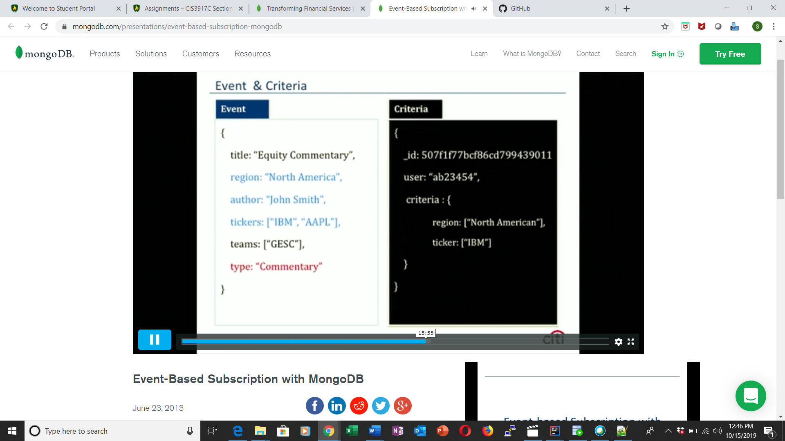

Event is an incoming document that someone have just published., that gets send to JMSQ which then gets pick up by application . blue fields indicate the subscribe of the document.

Exmaple of what query will look like

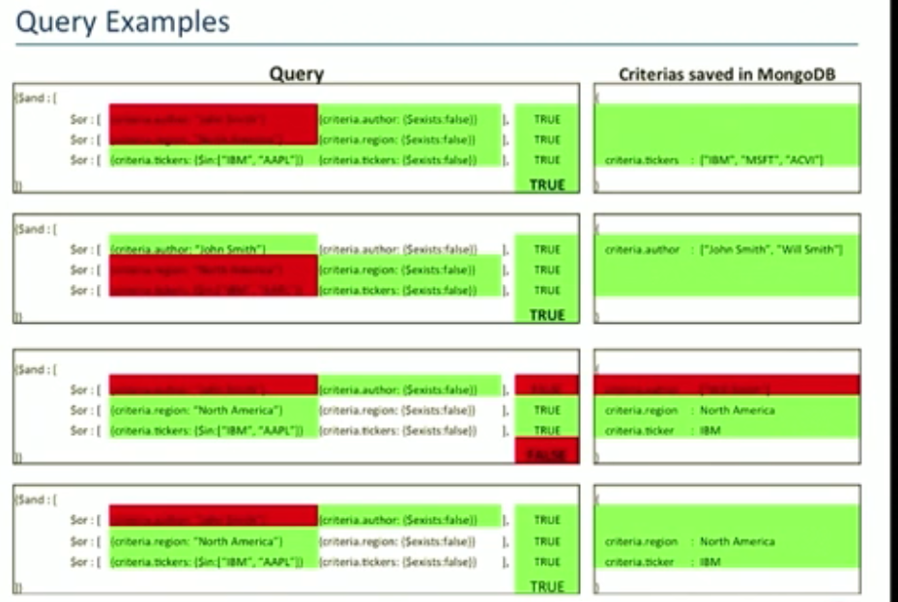

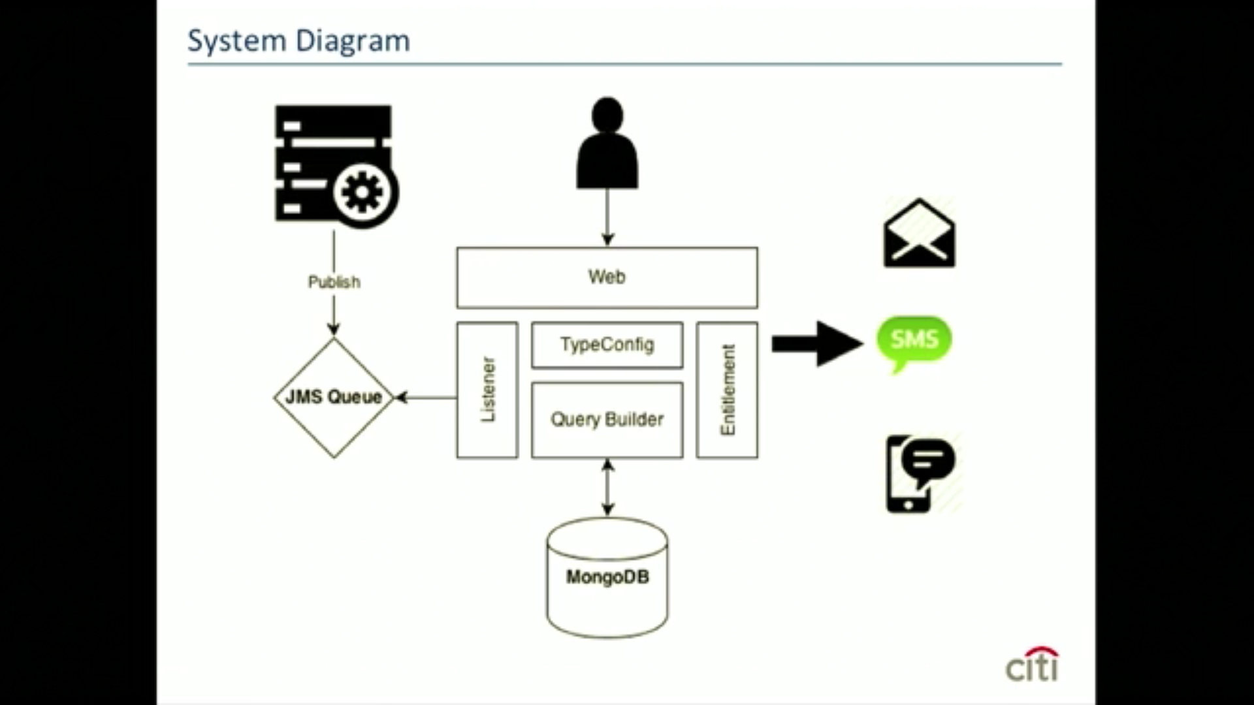

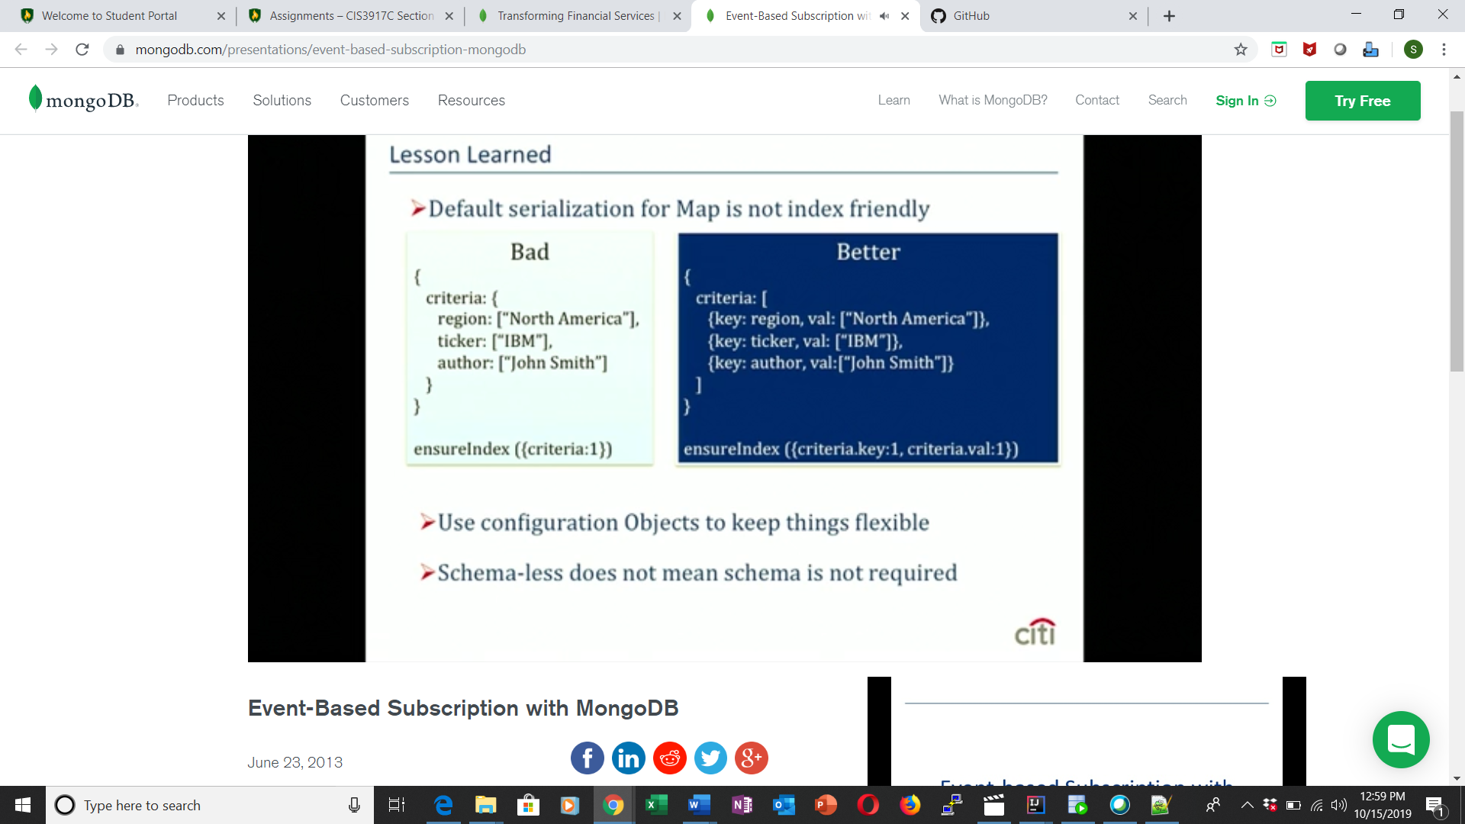

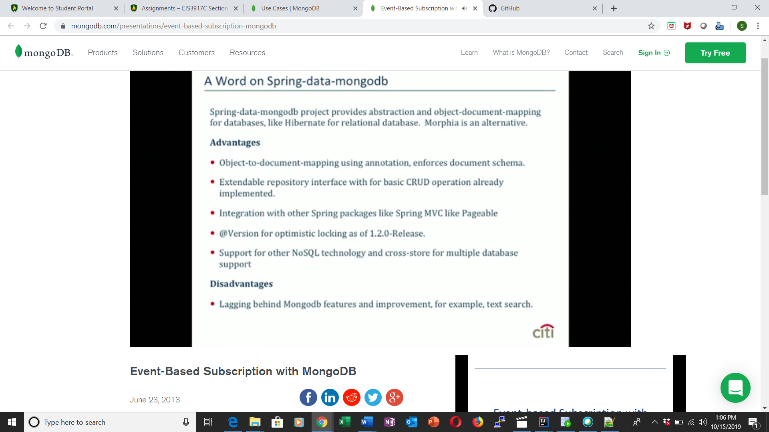

1. How did a distributed database system help the company provide a solution?
2. What are 2-3 examples of new capabilities with this system?